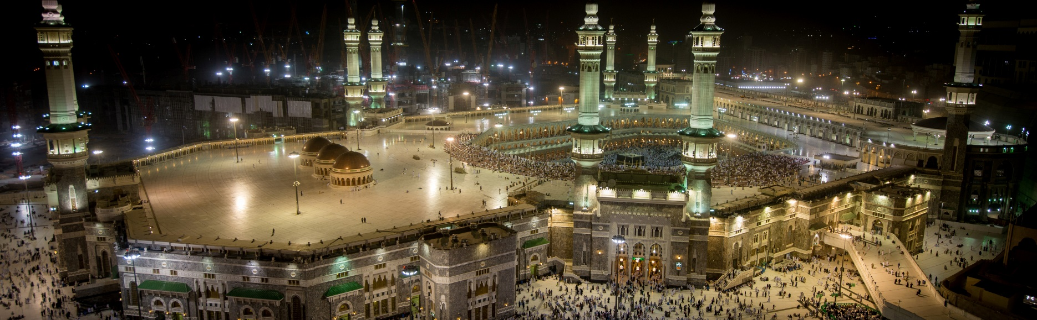

|  |  |
| --- | --- |
| Departure Date: |  |
| Arrival Date: |  |
| Destination: |  |

**Itinerary**

**Day 1: Arrival in Jeddah**

* Arrive at King Abdulaziz International Airport, Jeddah.
* Transfer to hotel in Makkah.
* Check-in and rest.

**Day 2-5: Makkah**

* Perform Umrah rituals.
* Visit the Holy Kaaba and Masjid al-Haram.
* Explore historic sites in Makkah.

**Day 6: Travel to Madinah**

* Check out from hotel in Makkah.
* Travel to Madinah by private bus.
* Check-in at hotel in Madinah.

**Day 7-10: Madinah**

* Visit the Prophet's Mosque (Masjid al-Nabawi).
* Offer prayers at the Rawdah.
* Explore key sites in Madinah.

**Day 11: Return to Jeddah**

* Check out from hotel in Madinah.
* Travel to Jeddah.
* Optional: Visit historical sites in Jeddah.

**Day 12: Departure**

* Depart from King Abdulaziz International Airport, Jeddah.

**Accommodation**

* Makkah: [Hotel Name and Address]
* Madinah: [Hotel Name and Address]

**Transportation**

* Airport transfers provided.
* Private bus for travel between Makkah and Madinah.

**Important Contacts**

* Emergency Contact: [Local Emergency Number]
* Tour Operator: [Tour Operator's Contact Details]

**Notes**

* Follow all Umrah rituals and guidelines.
* Respect local customs and traditions.
* Stay hydrated and take necessary precautions during the journey.